Purification and characterization of a novel cold-adapted β-galactosidase from a newly isolated strain of Erwinia rhapontici

School of Food Science and Technology, Jiangnan University, Wuxi 214122, China
Abstract
A β-galactosidase producing bacterial strain E602 was isolated from frozen soil and identified to be Erwinia rhapontici. This strain was cultured at 26℃ with the induction of lactose for production of β-galactosidase. The enzyme was then purified with ammonium sulfate fractionation, ion exchange and gel filtration chromatography for further studies of the enzymatic characteristics. The purified enzyme had a molecular weight of about 100 kDa. The optimum reaction temperature and pH of this enzyme was 40℃ and pH 7.0 respectively, indicating that this enzyme was a mesophilic neutral β-galactosidase. However, the enzyme retained about 15% activity at 10℃, which also suggested cold-adapted property of it. Kinetics of this enzyme was studied and the K_{m} and V_{max} of this enzyme was 0.21 mmol/l and 263.16 µmol/mg min⁻¹. Metal ions such as Li⁺, K⁺, Mg²⁺ and Zn²⁺ can activate the enzymatic activity obviously, while Cu²⁺ and Fe²⁺ inhibited its activity. This enzyme showed trans-glycosylation activity with lactose. The lactose hydrolysis in milk had been also investigated and results suggested that this enzyme may be suitable for milk processing.

Key Words: β-Galactosidase; Erwinia rhapontici; Isolation and Purification; Enzymatic Characteristics; Cold-adapted
Introduction
β-galactosidase (EC3.2.1.23) is a kind of glycoside hydrolase which can hydrolyze β-1,4-D-galactosidic linkage in lactose (Hildebrandt et al. 2009). This enzyme is applied in dairy industry for elimination of milk lactose in order to prevent the symptom of lactose-intolerance in human beings, and it is also widely used in other food industrial areas(Panesar et al. 2010). In industry, the β-galactosidases are mainly mesophilic enzymes from microbial origin, such as those from Kluyveromyces and Aspergillus(Dagbagli and Goksungur 2008;), so that the lactose hydrolysis treatments processing are usually carried out at moderate temperatures, which might cause undesired microbial contaminations during the time of processing (Wanarska et al. 2005).
In recent years, cold-adapted enzymes are of high interest in industry because they have some advantages over mesophilic enyzmes. For example, cold-adapted enzymes can catalyze reactions at low temperatures, which might avoid loss of nutrition in foodstuffs and eliminate microbial spoilages of foods to a great extent (Ramli et al. 2011). Furthermore, the cold-adapted enzymes have high stability and high catalytic efficiency at low temperatures so that the energy cost of the processing could be reduced (Hildebrandt et al. 2009; Ramli et al. 2011), on the other hand, the cold-adapted enzymes can be inactivated at moderate temperatures without heating (Nakagawa et al 2007). Nowadays, there are increasing reports on the researches of cold-adapted β-galactosidases and the β-galactosidases which have good enzymatic activities under low or cold temperatures are now been a research focus. Main of these enzymes are derived from Antarctic bacteria such as Pseudoalteromonas sp., Arthrobacter sp. and Paracoccus sp.(Turkiewicz et al. 2003; Białkowska et al. 2009;Wierzbicka-Woś et al. 2011).

In this work, we report a novel isolated β-galactosidase which has relative good activity in low temperatures. This enzyme was obtained from the newly isolated Erwinia rhapontici strain E602 which was screened from frozen soil. The β- galactosidase was massively obtained by fermentation of the strain E602 and purified by salting-out, dialysis, ion-exchange chromatography and gel filtration chromatography. The enzymatic activity and the ability for hydrolysis of lactose in milk and the transgalactosylation activity were also investigated.
Materials and Methods
Reagents
Ortho-Nitrophenyl-β-D-Galactopyranoside (ONPG) and dithithreitol was purchased from Sangon Biotech (Shanghai, China). Acetonitrile was purchased from Sigma-Aldrich (Shanghai, China). Molecular weight protein marker was purchased from Fermentas (Shanghai, China). Protein determination kit was purchased from Zoman Biotechnology (Beijing, China). Glucose determination kit was purchased from Rongsheng Biotech (Shanghai, China). Medium components such as tryptone and yeast extract were purchased from Oxoid (Thermo Fisher Scientific, UK). Other reagents were of AR grade.
Strain isolation and identification
A sample of frozen soil taken from suburban forest farm in Qiqihar (Heilongjiang Province, China) was used as the origin of bacteria strains which produced cold-adapted β-galactosidase. The TSA (tryptone 15 g/l, soya peptone 5 g/l, K₂HPO₄ 2.5 g/l, lactose 2.5 g/l, yeast extract 3 g/l, NaCl 5 g/l, Agar 15g/l, pH 7.3-7.5) medium was used for screening and isolation of the target bacteria strains. A 10 g sample of the soil was added to 100 mL TSA liquid medium without agar and cultivated at 12℃ with shaken at 200 rpm. After 48 h of cultivation, the culture was 10-fold diluted and plated on the surface of TSA medium supplemented with lactose (2.5 g/l) and X-gal (5-bromo-4-chloro-indolyl-β-D-galactopyranoside, 20 mg/mL), followed by incubation at 12℃ for 72 h. Then the blue colonies on the plates were all picked up and inoculated in TSA liquids supplemented with lactose (2.5 g/l) for further investigation of β-galactosidase activities at different temperatures. The strain with highest β-galactosidase activity at low temperatures were selected as the target strain of this work. This strain was preserved as glycerol (15%) stock at -70℃.
The cell and colony morphology of the target strain was determined by gram staining and microscopy. For identification of the target strain in a molecular approach, the 16s rDNA sequence was amplified by PCR using chromosomal DNA from the target strain as template. The primers for this experiment was 27F(5'- AGA GTT TGA TCC TGG CTC AG -3') and 1391R(5'-(GAC GGG CRG TGW GTR CA-3'). The amplified strand was subjected to DNA sequencing in Biosune Biotechnology co, Ltd (Shanghai, China) for further analysis. The online sequence alignment program NCBI BLASTN2.2.26+ (Zheng Zhang, Scott Schwartz, Lukas Wagner, and Webb Miller (2000), "A greedy algorithm for aligning DNA sequences", J Comput Biol 2000; 7(1-2):203-14.) was used for comparing and analyzing the sequence identity with the data of bacterial 16S ribosomal RNA. Phylogenetic tree was inferred using the alignment data with software ClustalX1.83 and MEGA3.1. For identification of the target strain with physiological and biochemical experiments, utilization of various carbon sources and acid production from various sugars was tested according to methods previously described (Geider et al. 2006; Hauben & Swings, 2005).
Production of β-galactosidase
The E. rhapontici E602 strain was activated on TSA medium at 26℃ for 24 h. A single colony of the strain was inoculated in 5 ml TSA liquid and cultivated with shaking at 26℃ for 12 h. Aliquots was taken from the culture and inoculated at a ratio of 1% (volume) into 100 ml TSA liquid in a flask and cultured at 26℃ for 15 h. Then the secondary seed was inoculated at a ratio of 1% (volume) into a 5 l TSA liquid supplemented with lactose (2.5 g/l) in a fermentor (New Brunswick Scientific, USA) and fermented at 26℃ for 18 h with an agitation speed of 200 rpm.
Purification of β-galactosidase
The culture of E. rhapontici E602 was harvested from fermentor and subjected to centrifugation at 4℃ and 10,000 g for 30 min on Beckman Avanti J-26xp centrifuge (Beckman Coulter Inc., Fullerton, CA) and then treated with sonication. The supernatant was collected after centrifugation at 4℃ and 21,000 rpm for 30 min on Beckman Avanti J-26xp centrifuge, and then the ammonium sulfate salting out was performed. The supernatant was treated with 20% ammonium sulfate saturation and then centrifuged at 4℃ and 10,000 g for 10 min. After centrifugation, the sediment was discarded and the supernatant was brought to 40% ammonium sulfate saturation and centrifuged at 4℃ and 10,000 g for 10 min again. Then the sediment was dissolved in 10 mmol/L PBS (phosphate buffered saline buffer, pH 7.0), and dialyzed at 0℃ for 12 h. The resultant solution was subjected to anion exchange chromatography, followed by gel filtration chromatography.
Anion exchange chromatography was performed on an AKTA purifier system (GE Healthcare, Sweden) using a HiPrep 16/10 DEAE column and equilibrated with 20 mmol/L Tri-HCl (pH 7.0). The target enzyme was eluted by a solution (containing 2 mol/l NaCl and 20 mmol/L Tri-HCl, pH 7.0) at gradient (volume) of 10%, 15%, 27%, 33% and 40%. The elution speed was 5 ml/min. Gel filtration chromatography was also performed on AKTA purifier system using a HiPrep 16/60 Sephacryl S-100 column (GE Healthcare, Sweden). The β-galactosidase was eluted in 50 mmol/l PBS buffer (150 mmol/l NaCl, pH 7.0) at 0.5 ml/min.
Enzyme activity assay
The β-galactosidases activity was determined as described by Gist-Brocades[10], except that the incubation temperature of the enzyme was adjusted to 40℃ and pH was adjusted to 7.0. One unit of enzyme activity was defined as the amount of enzyme hydrolyzing 1 μmol of substrate ortho-nitrophenyl-β-D-galactopyranoside (ONPG) per minute. The specific activity of β-galactosidases was expressed in units per milligram of enzyme protein.
Effects of temperature, pH and various reagent on enzyme activity
The effect of temperature on enzyme activity was determined at temperatures ranging from 0 to 60℃. The thermostability of the enzyme was tested by incubation of the enzyme at temperatures ranging from 10-50℃ for 6 h. The effect of pH on enzyme activity was determined at 40℃ in buffers which pH ranged from 4.0 to 9.0. The pH stability profile of enzyme was determined by incubation of this enzyme at 4℃ for 1 h in PBS buffers (pH 4.0-9.0). The effects of these factors were evaluated by determination of the residue enzyme activity.
The effect of various reagents on enzyme activity was determined by assaying the residue activity after incubating the enzyme in 1 to 10 mmol/l of the reagents (dissolved in PBS buffer, pH 7.0) at 25℃ for 20 min. The cations tested were Li⁺, Na⁺, K⁺, Mg²⁺, Ca²⁺, Zn²⁺, Cu²⁺, Fe²⁺, Mn²⁺, and Pb²⁺. The thiol reagents 2- mercaptoethanol and dithiothreitol, the enzyme inhibitors p-chloromercuribenzoic acid and the chelating agent ethylene diamine tetraacetic acid (EDTA) were also examined. Relative activity was estimated in above experiments by comparison to the highest activity (100%).
Kinetic analysis of β-galactosidase
The kinetic parameters (K_{m} and V_{max}) were calculated from Lineweaver-Burk plots using ONPG as a substrate. The ONPG concentration ranged from 0.80 mmol/l to 10 mmol/l. All the experiments were carried out at 40℃ and pH 7.0.
Hydrolysis of lactose in milk
Fifteen units of the purified β-galactosidase was added to 5 ml fresh milk (containing 5% (w/v) lactose). The solution was incubated at different temperatures ranging from 0 to 40℃ for 12 h. One hundred micro-liter of the aliquots was withdrawn every 2 h from the incubation and the β-galactosidase in which was denatured by adding 10% trichloroacetic acid. After centrifugation, the supernatants were subjected to glucose concentration analysis in order to evaluate the hydrolysis ratio of milk lactose.
Trans-glycosylation of lactose by β-galactosidase and the galactooligosaccharides assay
Forty-five units of the purified β-galactosidase was added to 5 ml lactose solution (300 mg/ml). The solution was incubated at 40℃ for 12 h. Five hundred micro-liter of the aliquots was withdrawn every 2 h of incubation. The aliquots were incubated in boiling water for 2 min to inactive the enzyme, followed by detection of galactooligosaccharides with LC-MS.
Results and Discussion
Isolation and identification of a β-galactosidase producing strain E. rhapontici E602
According to the methods described in this work, a total of 80 isolates from frozen soil which showed blue colonies on TSA plates supplemented with lactose and X-gal were picked up for β-galactosidase assays. Fifteen isolates of which produced β-galactosidase active at low temperatures (0-20℃). The strain with the highest β-galactosidase activity at 20℃ was named E602. Cell of strain E602 was rod-shaped, 0.5-1.0 μm wide by 1.0-2.0 μm long, occuring singly or in pairs, gram-negtive and non-endospore-forming. This strain showed milky white colony with a little metallic sheen on TSA medium, and it had a growth temperature range of 4-30℃ with optimum growth at 26℃.
For identification of this strain, the 16S rRNA gene was amplified by PCR from the chromosome of E602. The 1.5 kb amplified sequence was subjected to BLAST alignment with bacterial 16S rRNA gene online (http://blast.ncbi.nlm.nih.gov). The BLAST analysis showed that strain E602 shared the highest and same similarity (98%) with Erwinia tasmaniensis DSM 17950, Erwinia rhapontici DSM 4484, Erwinia persicina ATCC 35998 and Erwinia amylovora DSM 30165. The phylogenetic trees (Fig. 1) were obtained by using the least-squares, maximum-parsimony and neighbour-joining algorithms (Dastager SG, Lee J-C, Ju Y-J, Park D-J, Kim C-J. Leifsonia kribbensis sp. nov., isolated from soil. International journal of systematic and evolutionary microbiology. 2009;59(Pt 1):18-21.). So the 16S rRNA analysis results suggested that strain E602 belong to the genus Erwinia.
In order to identify strain E602 to species, the physiological and biochemical experiments was done to test the utilization of various carbon sources and acid production from various sugars. The results were listed in Table 1. These results indicated that strain E602 was identified as Erwinia rhapontici.
Production and purification of β-galactosidase from E. rhapontici E602
E. rhapontici is a kind of gram-negative bacterium which can be used for production of enzymes and additives for food industry ^{[11]}, and this strain is not pathogenic to animals and human beings. In this work, the strain E. rhapontici E602 was cultivated with induction of lactose for production of β-galactosidase. The enzyme was firstly treated with ammonium sulfate precipitation. After that, the target enzyme was further purified by 2-step separations: the anion exchange chromatography (Fig. 2) and the gel filtration chromatography (Fig. 3). As shown by Fig. 2, the target enzyme showed a single high peak on the graph. The elution correspondent to the peak was collected for gel filtration chromatography. In Fig. 3, there was only one peak on the graph, and the elution correspondent to this peak was collected for β-galactosidase enzyme activity assay. The purification procedures and results of the β-galactosidase are summarized in Table 2 which depicts specific activity and the purification fold of every step. After these purification procedures, the final enzyme activity reached 177.00 U/mg protein. The enzyme samples of every purification step were subjected to 12% SDS-PAGE analysis and the final purified β-galactosidase showed a single band of about 100 kDa (Fig. 4).

Temperature and pH profiles of β-galactosidase
The effect of temperature on the enzyme activity was studied at temperatures ranging from 0 to 60℃ at pH 7.0 (Fig. 5). The purified enzyme showed the maximum activity at 40℃. However, the enzyme retained about 15% of the activity at 10℃, which also suggested cold-adaptive property of this enzyme. Thermostability of the enzyme was determined by incubation at 10, 20, 30, and 40℃ for 6 h (Fig. 6) and at 50℃ for 30 min (Fig. 7). Results showed that the enzymatic half-life of the β-galactosidase at 10, 20, 30, 40, and 50℃ were 13 h, 11 h, 8 h, 7 h and 2 min respectively.
The pH profiles of the enzyme were shown in Fig. 7 and Fig. 8. The enzyme displayed its maximum activity at pH 7.0 (Fig. 8) and retained more than 80% of its activity at the pH range of 6.5 to 7.5, which is a good property with respect to milk processing because the pH of milk is near to 6.7. The pH stability was determined by initial incubation at 4℃ for an hour in PBS buffer (pH 4.0-9.0), followed by activity determination under standard conditions (Fig. 9).

Effects of metal cations, EDTA, thiol reagents and inhibitors on enzyme activity of β-galactosidase
According to the results listed in Table 3, the cations Li⁺, K⁺, Mg²⁺ activated the enzyme activity and Cu²⁺, Fe²⁺, Pb²⁺ inhibited the enzyme activity. Chelating agent EDTA inhibited the enzyme activity. Enzyme inhibitors displayed inhibition against the enzyme while thiol reagents revealed some promotion effects.

Effects of substrate or substrate-like molecules on enzyme activity of β-galactosidase
The enzyme kinetic parameters for ONPG or other substrate-like inhibitors were calculated from a Lineweaver-Burk plot. The K_{m} and V_{max} values for ONPG were 0.184 mmol/L and 263.16 μmol/mg pro·min (Fig. 10). The substrate-like inhibitors, glucose (100 mmol/L), lactose (10 mmol/L) and galactose (100 mmol/L) were added to obtain the inhibitor constant value K_{i} according to the inhibitor substrate concentration. The results showed that lactose and galactose had a competitive inhibitor effect against ONPG (Fig. 11). The inhibitory activity of lactose was greater than galactose. The K_{i} for lactose and galactose was 7 mmol/L and 36.84 mmol/L, respectively.
Galactooligosaccharide production by β-galactosidase from E. rhapontici E602
The galactooligosaccharide produced by trans-glycosylation reaction of lactose was determined by LC-MS. The sample of lactose standard and the lactose hydrolysis solution were showed in Fig. 13 and Fig. 14, respectively. The component which showed a peak at 12.46 min in Fig. 13 was determined to be a kind of trisaccharide and its molecular weight was 504 (Fig. 15). These results showed that the β-galactosidase produced by E. rhapontici E602 can effectively transform the lactose into galactooligosaccharide.

Hydrolysis of Lactose in milk by β-galactosidase from E. rhapontici E602
The lactose hydrolysis ability of the purified β-galactosidase from E. rhapontici E602 was tested with fresh milk at different temperatures (Fig. 12). Result showed that the hydrolysis rate of lactose reached 60% after 12 h of hydrolysis at 30℃. When the reaction was carried out at 40℃, 8 h was needed for hydrolyzing 50% of the lactose.

Conclusion
In this work, the β-galactosidase was produced by E. rhapontici E602 and was efficiently purified with several procedures. The optimum temperature of the enzyme is 40℃ and its optimum pH is 7.0 and the enzyme was stable from pH 5.0 to 8.0. Its thermostability was good from 10 to 40℃ and its thermostability was poor at 50℃. The metal ions Li⁺、K⁺、Mg²⁺ activated the enzyme activity and Cu²⁺, Fe²⁺, Pb²⁺ inhibited the enzyme activity. The K_{m} and V_{max} of this β-galactosidase was 0.184 mmol/L and 263.16 μmol/mg pro·min respectively using ONPG as substrate. These results indicated that this enzyme was proper for hydrolysis of milk lactose and production of low lactose milk product. Trisaccharide was efficiently formed during the process of lactose hydrolysis so that this enzyme may also be applied for galactooligosaccharide production.

Acknowledgement
This work was supported by the National Natural Science Foundation of China (Beijing) under Grant No. 31000752, the National Science and Technology Support Program of China (2012BAK08B01)，NCET-11-0663 and the Fundamental ResearchFunds for the Central Universities (JUSRP51309A)

Table and Figure Legends
Table 1 Physiological and biochemical characteristics of strain E602
Table 2 Purification of β-galactosidase from Erwinia rhapontici E602
Table 3 Effects of metal cations, EDTA, thiol reagents, and enzyme inhibitors on the β-galactosidase activity
Fig.1 The phylogenetic tree based on 16 S rRNA gene sequences. This tree was obtained using software MEGA3.1 by the Neighbor-Joining method. Numbers at branch nodes indicate bootstrap values of 1,000 trials (only values 50% were shown). Bar: 0.02 substitutions per nucleotide position.
Fig. 2 Results of anion exchange chromatography of β-galactosidase
Fig.3 Results of gel filtration chromatography of β-galactosidase
Fig. 4 SDS-PAGE analysis of the purified β-galactosidase from different stages. Lane 1: protein marker, lane 2: cell-free extracts, lane 3: fraction of (NH₄)₂SO₄ precipitation, lane 4: fraction of AKTA DEAE column, lane 5: fraction of AKTA Sephacryl S-100 column.
Fig. 5 Effect of temperature on activity of β-galactosidase. Error bars represent the standard deviation from 3 separate experiments.
Fig. 6 The thermostability of the β-galactosidase at different temperatures. ◆ 10℃; ■ 20℃;▲30℃; × 40℃. Error bars represent the standard deviation from 3separate experiments.
Fig.7 The thermostability of the β-galactosidase at 50℃. Error bars represent the standard deviation from 3separate experiments.
Fig.8 Effect of pH on activity of the β-galactosidase. Error bars represent the standard deviation from 3 separate experiments.
Fig. 9 The pH stability of the β-galactosidase. Error bars represent the standard deviation from 3 separate experiments.
Fig. 10 Lineweaver-Burk plot of the β-galactosidase
Fig. 11 Effect of substrate-like inhibitores on the activity of β-galactosidase
◆ control; ■ glucose (100 mmol/L); ▲ lactose (10 mmol/L); × galactose (100 mmol/L)
Fig. 12 Hydrolysis of lactose in milk by β-galactosidase. Error bars represent the standard deviation from 3 separate experiments.
◆ 0℃; ■ 4℃; ▲ 10℃; × 20℃; ○ 30℃; □ 40℃
Fig. 13 MS spectrum of lactose standard
Fig. 14 MS spectrum of lactose hydrolysis for 12 h
Fig. 15 Product ion spectrum of lactose hydrolysis at t=12.46 min

Table 1 Physiological and biochemical characteristics of strain E602
Characteristic | Result
Colony Color | Milky White
Motility | +
Growth Temperature (℃) | 4-30
Oxidase | -
Anaerobic Growth | +
H2S Production | -
Aerogenesis with Glucose | -
Indol Production | -
Casein Hydrolysis | -
Growth at 5% NaCl | -
ONPG Utilization | +
VP Test | -
Acid Production From | Glucose, Lactose, Galactose, Fructose, Sucrose, Maltose, Mannose, Cellobiose, Gentiobiose, Rhamnose, Melibiose, Trehalose, Melizitose, Melitose, D-Arabinose, L-Arabinose, Ribose, D-Xylose, L-Fucose, D-Fucose, D-Turanose, D-Lyxose, Glycerol, Esculin, Arbutin, Amygdalin, Salicoside, Inositol, Mannitol, Sorbitol, Xylitol, n-Acetylglucosamine, Methyl α-D-Methylglucoside, Methyl α-D-mannopyranoside

Table 2 Purification of β-galactosidase from Erwinia rhapontici E602
Steps | Total protein  (mg/ml) | Enzyme activity  (U/ml) | Specific activity  (U/mg) | Purification  (fold)
Cell-free extract  20 to 40% ammonium sulfate precipitation  Anion exchange  Gel filtration | 3.50  0.66  0.03  0.02 | 6.12  2.22  1.63  3.54 | 1.75  3.36  54.33  177.00 | 1.00  1.93  31.04  101.14

Table 3 Effects of metal cations, EDTA, thiol reagents, and enzyme inhibitors on the β-galactosidase activity
 | Concentration(mmol/L) | Relative Activity (%)
Control  Cations  Li⁺  Na⁺  K⁺  Mg²⁺  Ca²⁺  Zn²⁺  Cu²⁺  Fe²⁺  Mn²⁺  Pb²⁺  Thiol reagents  2-mercaptoethanol  Dithithreitol  Enzyme inhibitor  pCMB  Chelating agent  EDTA | 0  10  10  10  10  10  5  5  5  2  2  1  1  1  1 | 100.0  131.3  104.3  133.6  124.8  88.4  28.7  4.9  32.5  105.3  2.8  121.2  124.5  18.7  74.3

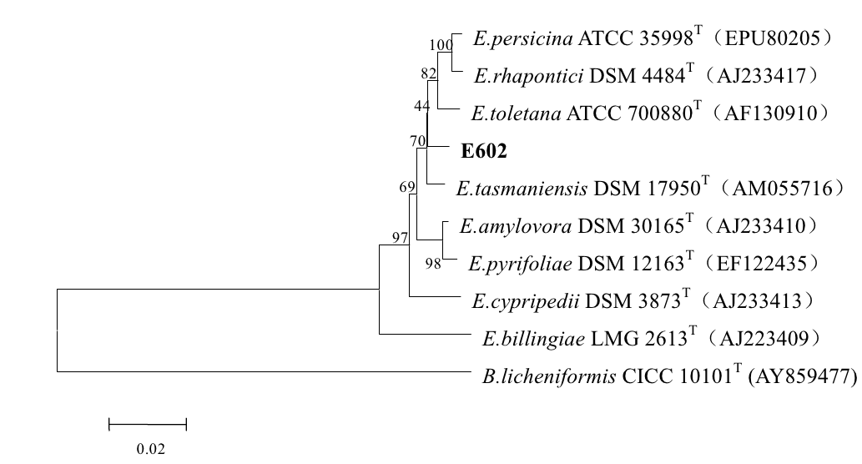
Fig.1 The phylogenetic tree based on 16 S rRNA gene sequences.
This tree was obtained using software MEGA3.1 by the Neighbor-Joining method. Numbers at branch nodes indicate bootstrap values of 1,000 trials (only values 50% were shown). Bar: 0.02 substitutions per nucleotide position.

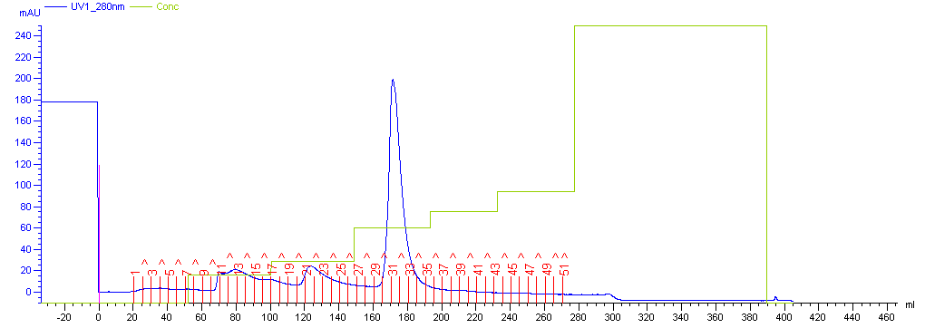

Fig. 2 Results of anion exchange chromatography of β-galactosidase

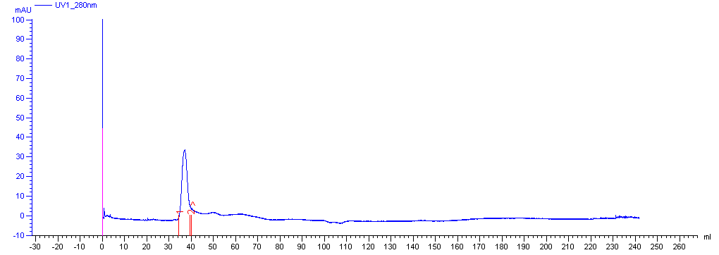
Fig.3 Results of gel filtration chromatography of β-galactosidase

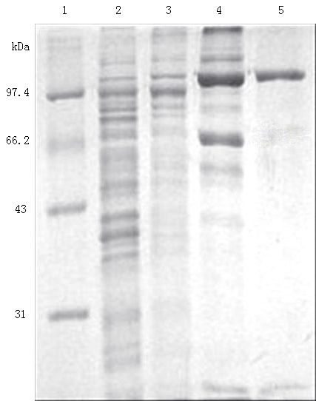
Fig. 4 SDS-PAGE analysis of the purified β-galactosidase from different stages.
Lane 1: protein marker, lane 2: cell-free extracts, lane 3: fraction of (NH₄)₂SO₄ precipitation, lane 4: fraction of AKTA DEAE column, lane 5: fraction of AKTA Sephacryl S-100 column.

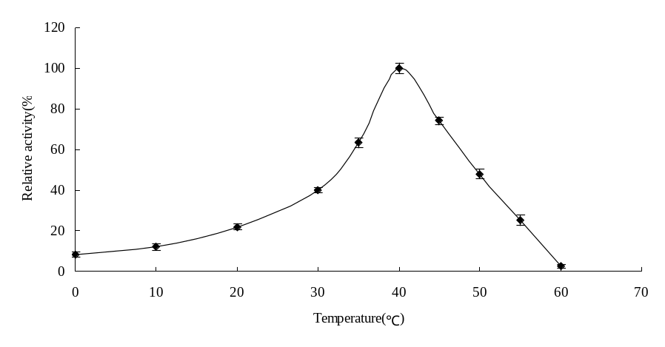
Fig. 5 Effect of temperature on activity of β-galactosidase. Error bars represent the standard deviation from 3 separate experiments.

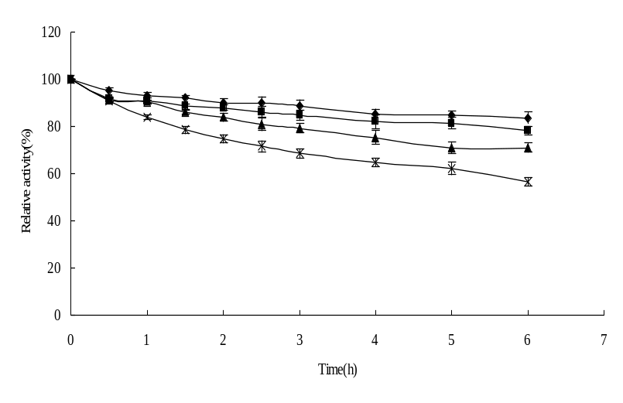
Fig. 6 The thermostability of the β-galactosidase at different temperatures. ◆ 10℃; ■ 20℃;▲30℃; × 40℃. Error bars represent the standard deviation from 3separate experiments.

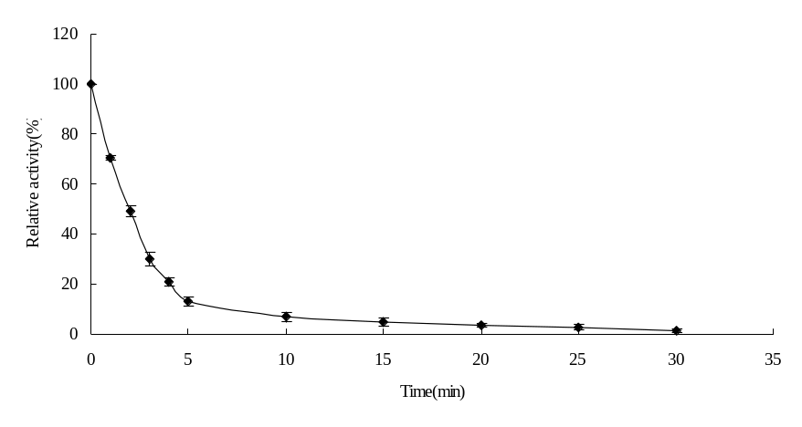
Fig.7 The thermostability of the β-galactosidase at 50℃. Error bars represent the standard deviation from 3separate experiments.

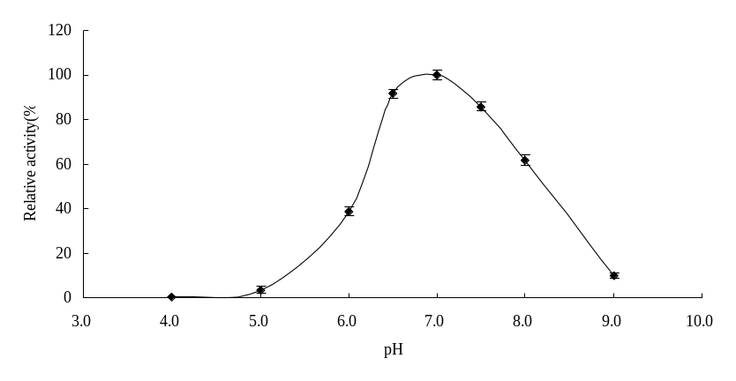
Fig.8 Effect of pH on activity of the β-galactosidase. Error bars represent the standard deviation from 3 separate experiments.

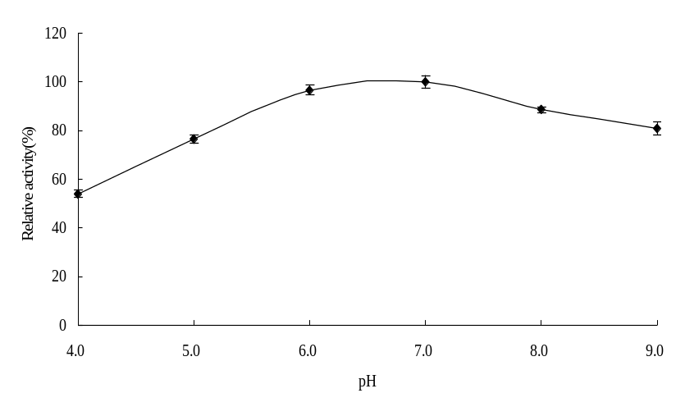
Fig. 9 The pH stability of the β-galactosidase. Error bars represent the standard deviation from 3 separate experiments.

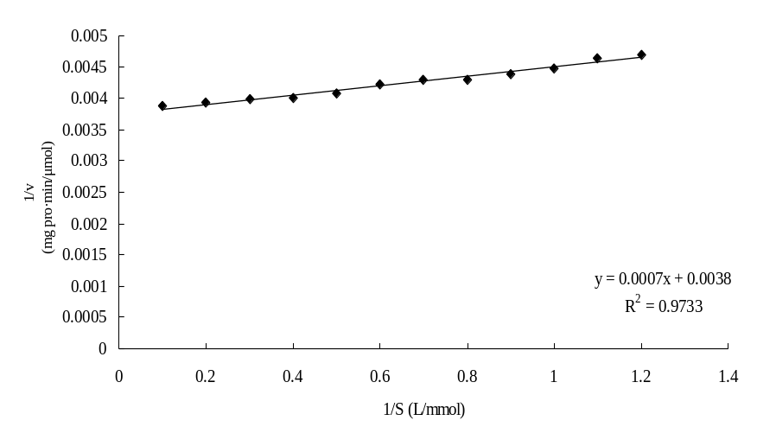
Fig. 10 Lineweaver-Burk plot of the β-galactosidase

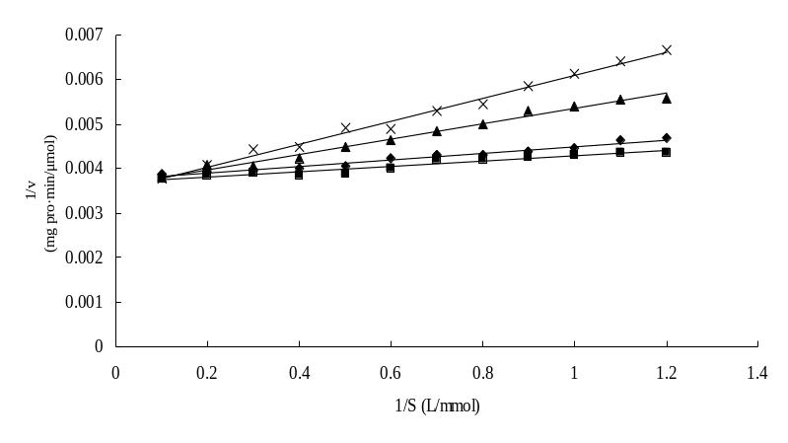
Fig. 11 Effect of substrate-like inhibitores on the activity of β-galactosidase
◆ control; ■ glucose (100 mmol/L); ▲ lactose (10 mmol/L); × galactose (100 mmol/L)

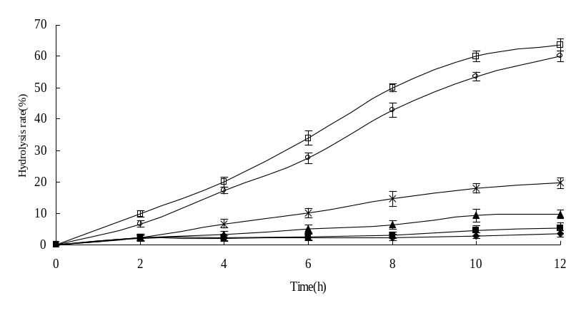
Fig. 12 Hydrolysis of lactose in milk by β-galactosidase. Error bars represent the standard deviation from 3 separate experiments.
◆ 0℃; ■ 4℃; ▲ 10℃; × 20℃; ○ 30℃; □ 40℃

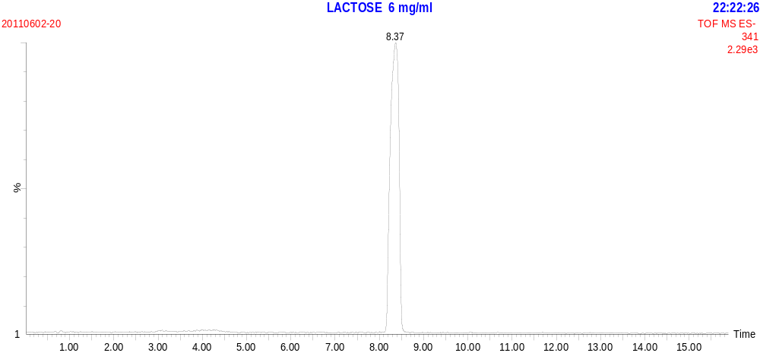

Fig. 13 MS spectrum of lactose standard

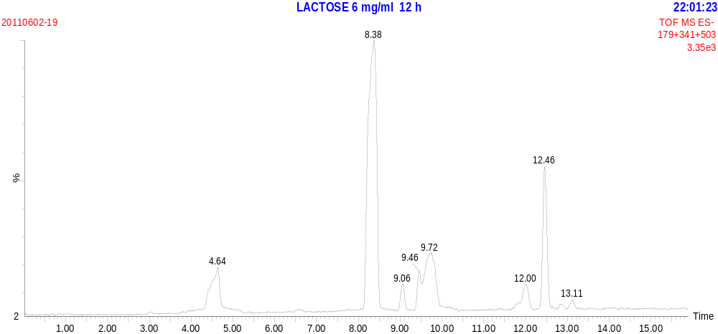

Fig. 14 MS spectrum of lactose hydrolysis for 12 h

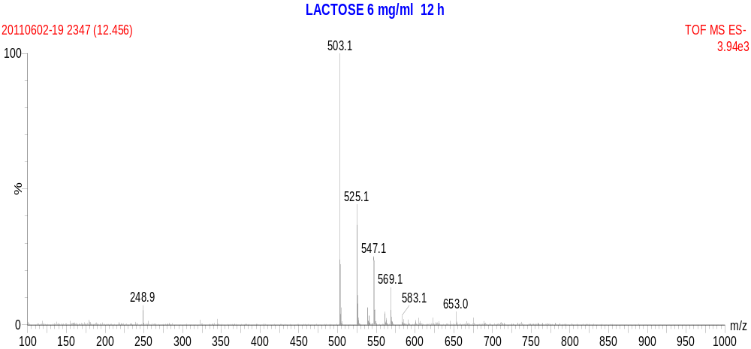

Fig. 15 Product ion spectrum of lactose hydrolysis at t=12.46 min

